**LAB # 11 & 12 TASK 1**

**Class Diagram for Graphics Editor**

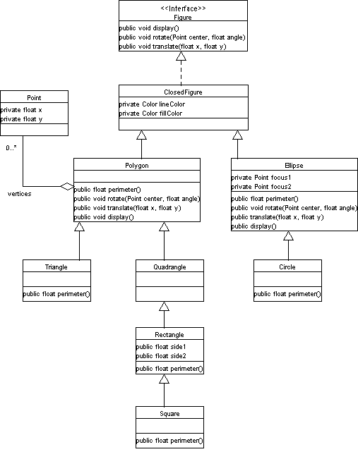

**LAB # 11 & 12 TASK 2**

**Sequence Diagram for Creating a file**

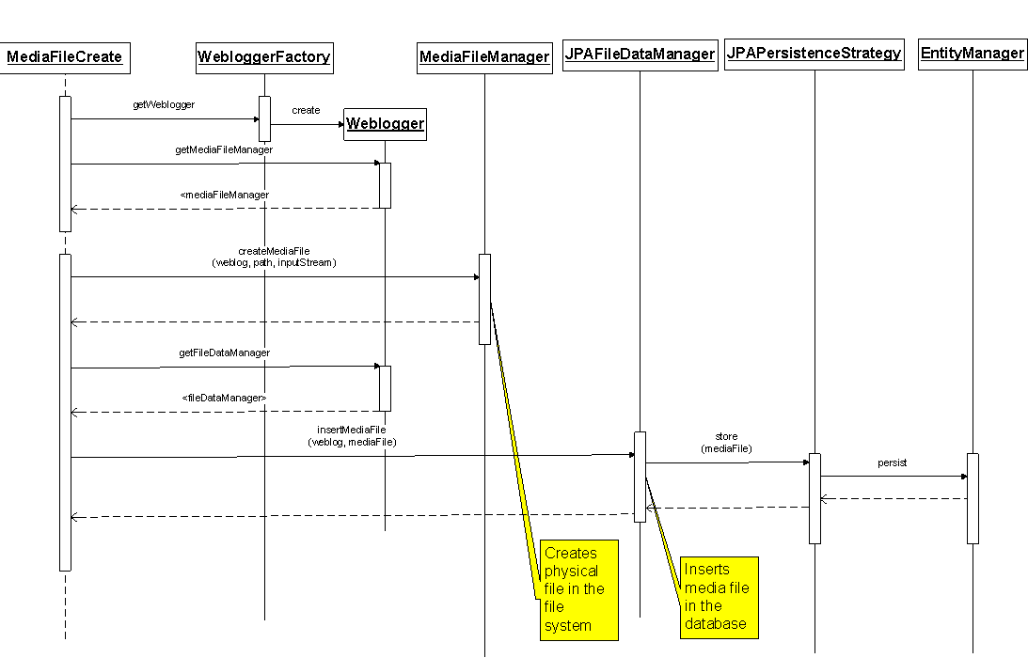

**LAB # 11 & 12 TASK 3**

**Sequence Diagram for Modifying a file**

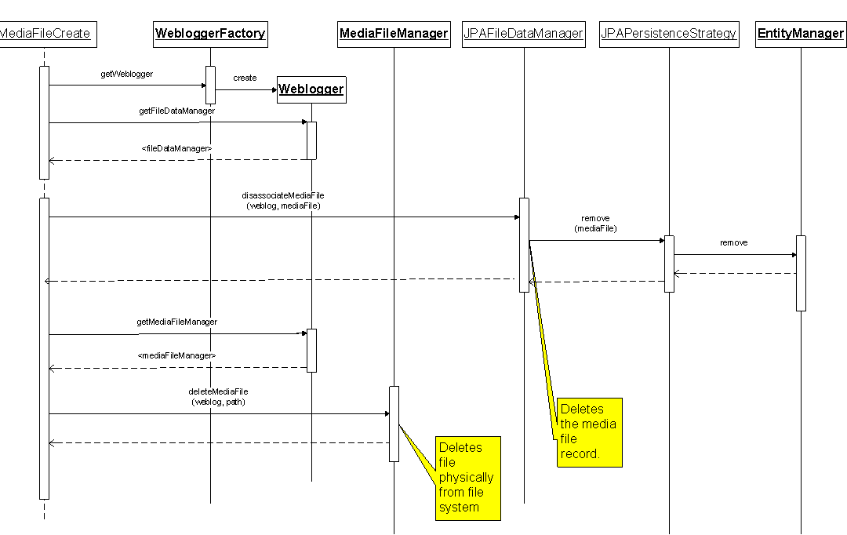

**LAB # 11 & 12 TASK 4**

**Collaboration diagram for graphics editor**

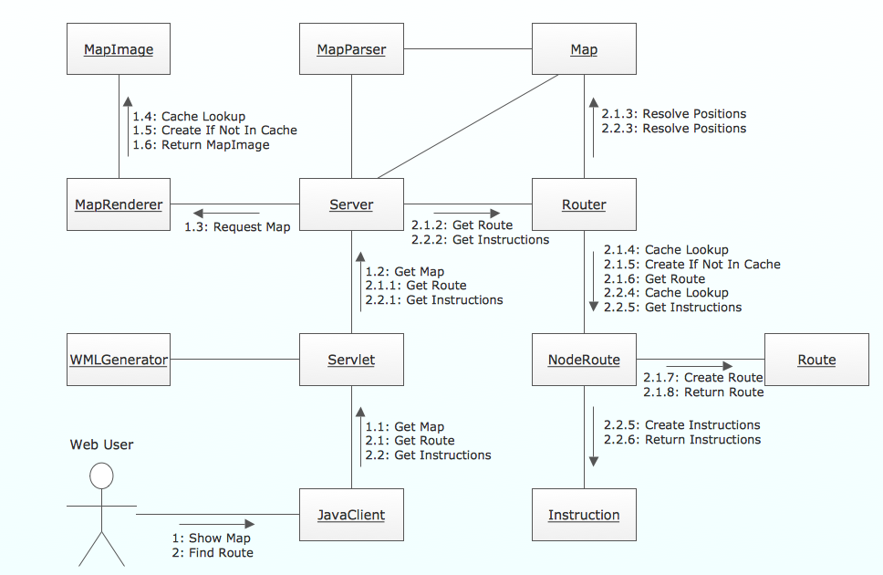

**LAB # 11 & 12 TASK 5**

**Component diagram for graphics editor**

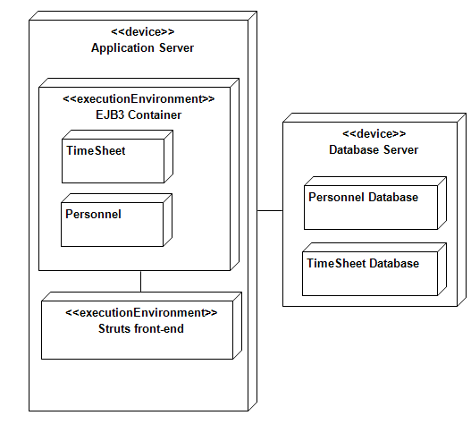

**LAB # 11 & 12 TASK 6**

**Deployment diagram for graphics editor**

